**Final Product**

***Ask Your Document GUI***

*Group 4*

Asia Jones, Kyra Jordan, Vincent Kipchoge, Matthew Krupczak, Isaiah Langford

**Team Members:** for each member indicate

A: did his/her share

B: did less than his/her share (explain if necessary)

C: did nothing

# 

**Ask Your Document GUI 3**

Synopsis: 3

Usage: 3

Future Implementation: 4

Installation (for users): 4

Windows Installation: 4

MacOS Installation: 4

Installation (for developers): 5

# 

# **Ask Your Document GUI**

## Synopsis:

This semester, our group has created a simple program which allows normal computer users to harness the power of an AI large language model for common knowledge work. This program allows a user to analyze large documents according to their given prompt to obtain specific information and insights from large documents. This may be useful for persons such as students, paralegals, and business professionals in their daily work.

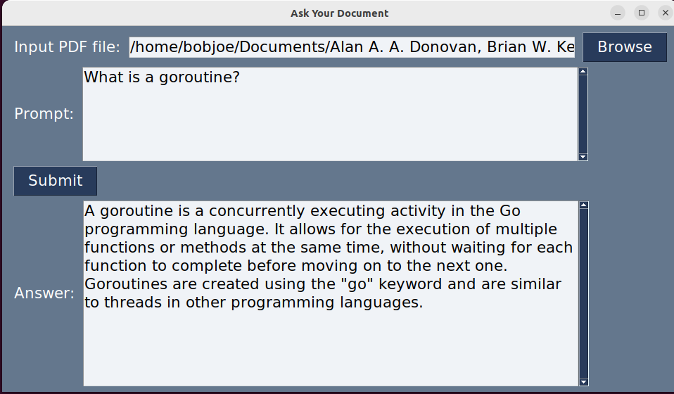

Figure 1: A screenshot of ask_your_document_GUI.app running on MacOS Ventura

## Usage:

After installation, you may run the program using the provided executable file. It may take up to a minute to launch, this is considered normal. Click on the “Browse” button to select a pdf document containing text you wish the program to analyze. In the “Prompt” field, provide a question or request for certain information contained within the document. Finally, click the “Submit” button. Within about 20 seconds, an answer will appear in the “Answer” field, usually containing the information you are looking for.

Note: This program can only interpret text, not images contained within a pdf document. Large language models are not perfect, and can sometimes misrepresent facts or information in rare cases. Trust but verify any information provided in the “Answer” field.

## Future Implementation:

As part of future development, implementation can explore the possibility of expanding the program's language support. Currently, the AI language model can only understand and analyze text in the same language as the prompt, but in the future the application can possibly incorporate additional languages to cater to a more diverse user base. This will enable individuals from various linguistic backgrounds to benefit from the program's capabilities and use it effectively in their native languages.

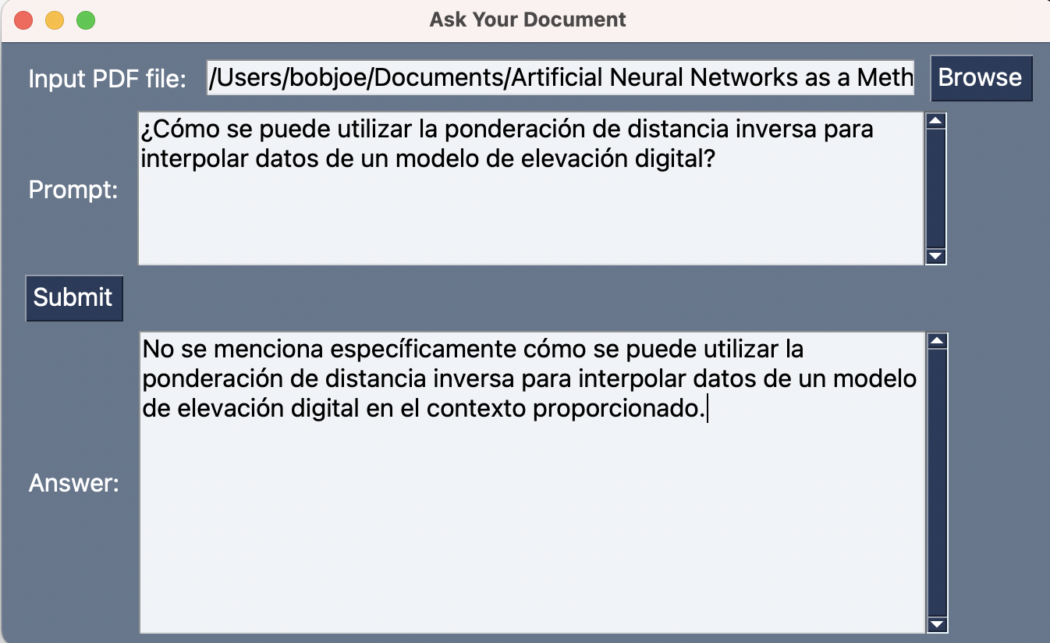

Figure 2: The program fails to find relevant context information from an English document with a prompt written in Spanish

## Installation (for users):

We have packaged the app in a self-contained executable for each MacOS and Windows computers. These versions are available at:  
<https://github.com/mkrupczak3/Ask-Your-Document/releases>

### Windows Installation:

For now, Windows users will need to follow the Installation (for developers) instructions.

Our team made significant efforts to build a self-contained executable release for Windows. Unfortunately, we encountered issues with how the llama_index package and its prerequisites were implemented in Python, making them incompatible with PyInstaller on Windows.

This is an issue we can raise with the llama_index and PyInstaller projects in hopes it may be resolved in a future version.

The possibility of these technical issues we encountered (preventing this deliverable) was anticipated and noted in previous documents.

Our detailed build instructions for a self-contained executable are available here:

<https://gist.github.com/mkrupczak3/080782f97e04c9bb009f400fb80f3af5>

### MacOS Installation:

Note: This program will only work with Macs with Apple Silicon (2020 or newer).

On MacOS, download the .app.zip file from the GitHub link above, then in a Finder window double click the .zip file to extract from it the file **ask_your_document_GUI.app**. Drag and drop this file into “**Applications**” folder shown on the sidebar of your Finder window:

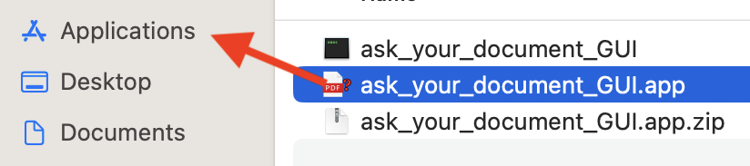

Figure 3: drag and drop the .app file into your Applications folder on MacOS

Next, attempt to open the app. By Default, MacOS does not allow this program to run because it was not signed by a certified developer for Apple products. To override this default and indicate that you trust this program, follow these instructions for your version of MacOS:  
  
<https://support.apple.com/guide/mac-help/open-a-mac-app-from-an-unidentified-developer-mh40616/mac>

## Installation (for developers):

For developers or users on platforms which do not support the packaged release above, please follow the following steps to install Python 3.11 and all necessary pre-requisite packages. You may then launch the program from your command line shell.  
  
Install Python 3.11 for your system:

<https://www.python.org/downloads/release/python-3114/>  
  
On Windows, make sure the following option is checked so your installation includes the prerequisite **tkinter** used by this program:vcv

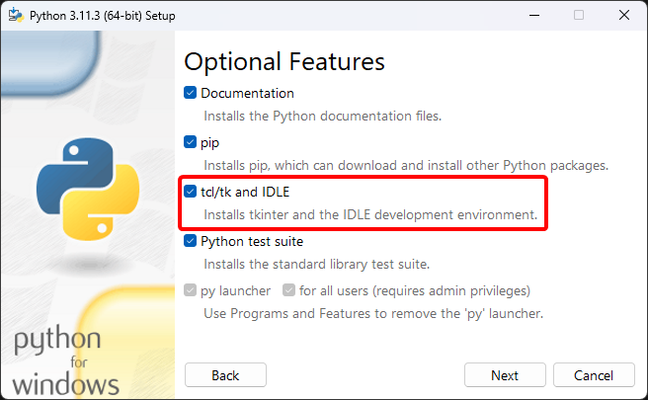

Figure 4: This option on the Windows installer for Python must be checked

On Linux or MacOS systems, you should instead install **tkinter** using your system’s package manager as described in the link below:  
  
<https://stackoverflow.com/a/74607246>

Next download the latest version of the project code from: <https://github.com/mkrupczak3/Ask-Your-Document>  
  
And extract it as a folder on your filesystem.

**cd** into the project folder using a command line shell window, then run the command:  
pip install -r requirements.txt

Next, run the following command to install another prerequisite:  
python download_loader_PyMuPDFReader.py

Now, obtain an API key from <https://platform.openai.com/account/api-keys>, and paste it into the file named **api.key** in the project directory.

Finally, use the following command to run the program:

python ask_your_document_GUI.py

Note: the name for the python executable may be “python3” or “python3.11” depending on your system.

## Video Demo (Mac):

<https://youtu.be/EAxRKCkmSZM>